AWS PROJECT 1

AIM: The aim of this project is to set up a Node.js application on AWS EC2 with an image gallery hosted on Amazon S3. The application features a completion page displaying a personalized congratulatory message.

NODEJS AND NPM INSTALLED VERSION
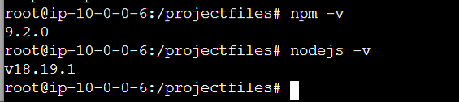

ADDED THE IMAGE URL FROM S3 OBJECT URL
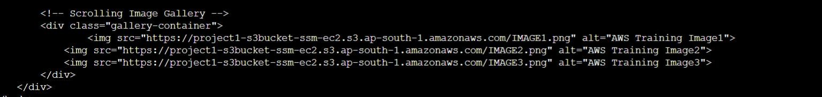

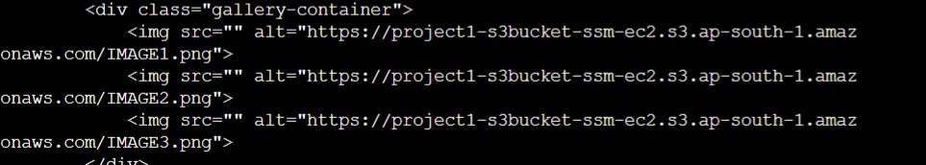
THE NAME ADDED TO THE CODE
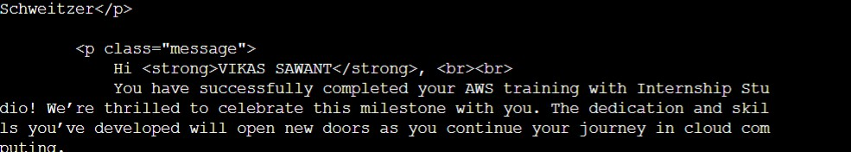

START WORKING WEBSITE ON PUBLIC IP
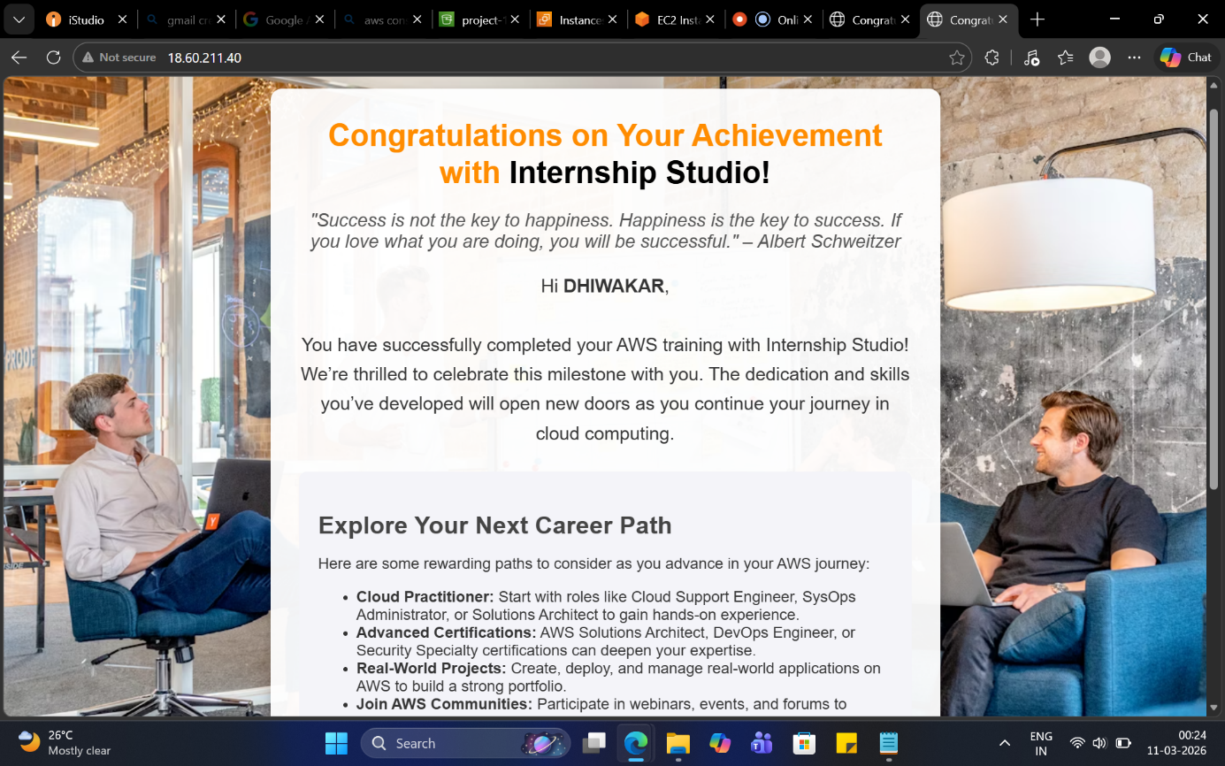

PUBLIC IP: 18.60.211.40

ADDED S3 BUCKET POLICY TO READ PUBLIC ACCESS


PROCEDURES:

- CREATE VPC
- CRETAE IAM ROLE FOR ACCESSING EC2 SYSTEM MANAGER
- CREATE S3 BUCKET UPLOAD IMAGE ASSIGNED BUCKET POLICY FOR PUBLIC ACCESS CREATE EC2 CONNECT WITH SEESION MANAGER

sudo su cd /
mkdir projectfiles sudo apt update sudo apt install npm
sudo apt install nodejs sudo apt install express npm -v
nodejs -v
fetch code file scp or create file vi completion.html vi app.js to open port
run commond sudo node app.js login with public IP and check

